Branching steps

1. Make sure you’ve committed everything to your branch
2. Make sure you ‘ve latest version of trunk code
3. Switch your working copy to trunk: Right click->TortoiseSVN->Switch.

Select your trunk URL, HEAD revision and press OK.

1. Right click on trunk -> TortoiseSVN - > Merge

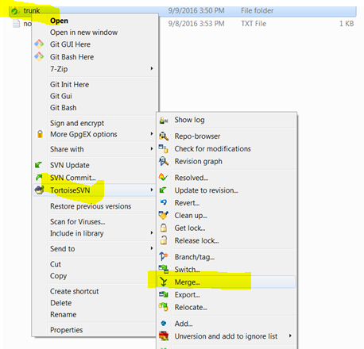

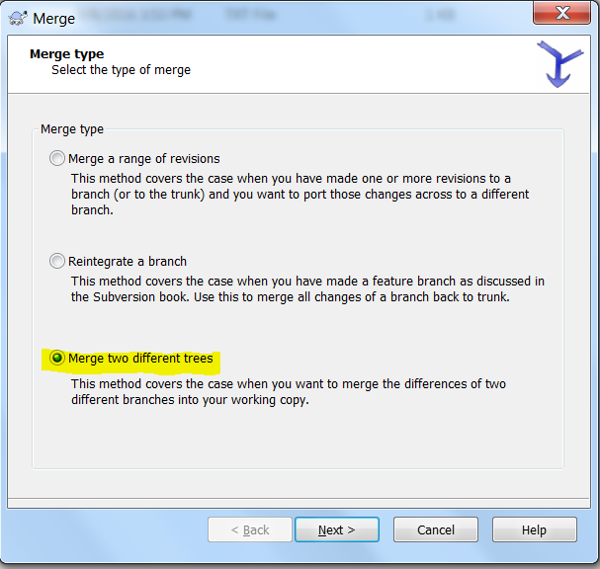

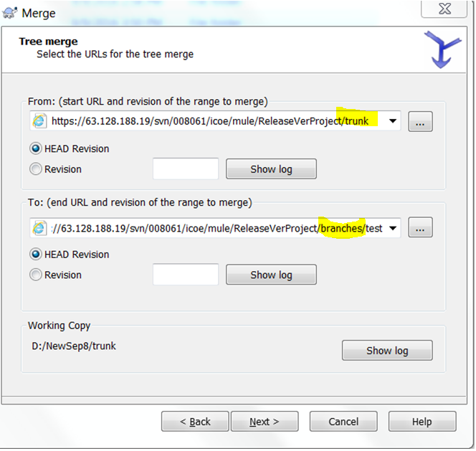

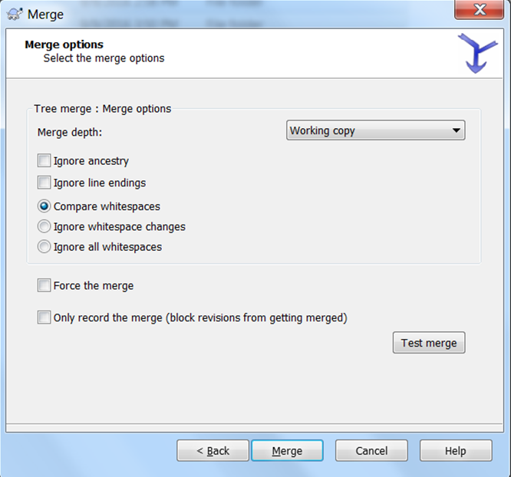

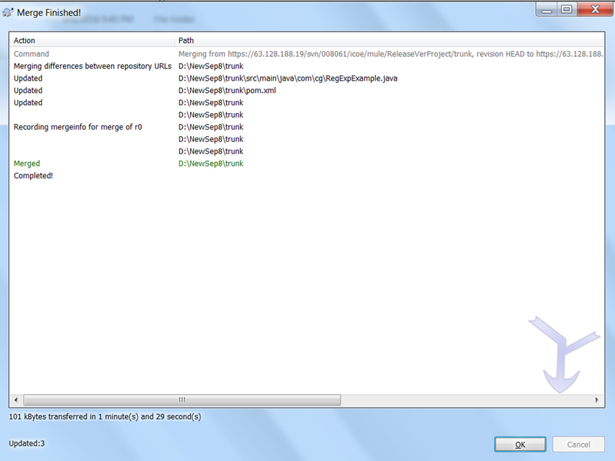

Click ok and commit trunk

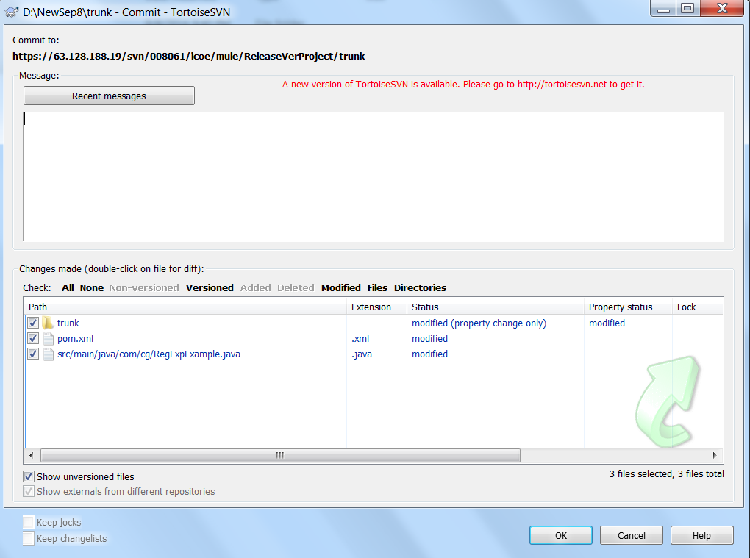

Done